Basic Sentence Parts and Patterns

 | Type | Example | Diagram
1 | Simple subject and predicate | Samson slept.
2 | Understood subject (for commands, directives) | Sit!
3 | Questions | Where are you going? | 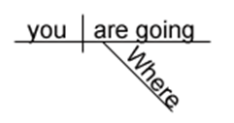
 |  | What were you reading this morning? | 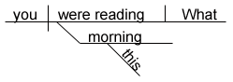
 |  | Whose bike were you using? | 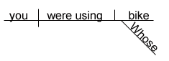
 |  | May I postpone this assignment?
4 | Compound predicate | The cat howled and scratched ferociously. | 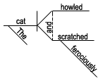
5 | Compound subject and compound predicate | Juanita and Celso worked hard and then rested. | 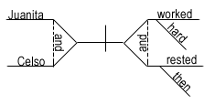
6 | Three subjects | Juanita, Federica, and Celso are working. | 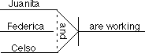
7 | Direct object | Tashonda sent e-mail.
8 | Compound direct objects | Tashonda sent cards and letters. | 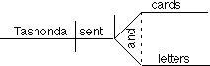
9 | Three direct objects | Tashonda sent e-mail, cards, and letters.
10 | Compound predicate with direct objects | Joselyn cooked breakfast and ate it. | 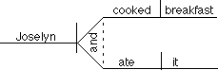
11 | Compound predicate with one direct object | Samantha proofreads and edits her essays. | 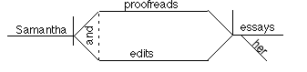
12 | Indirect object | Mrs. Doubtfire gave the children homework. | 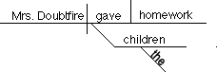
13 | Compound indirect objects | Mrs. Doubtfire gave Tabitha and Samantha quizzes. | 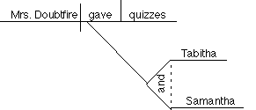
14 | Predicate noun | John Calhoun is a coach.
15 | Objective complement | Johnny painted his old jalopy purple. | 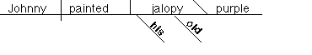
 |  | The club elected Tashonda [as its] president. | 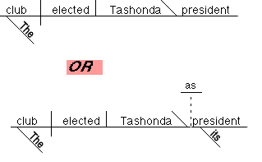
16 | Reflexive Pronouns | [as direct object] José cut himself.  [as indirect object] Mr. Edwards gave himself a raise.  [as object of a preposition] She cared only for herself. | 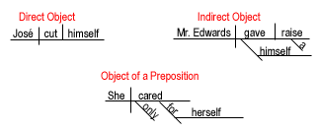
17 | Intensive Pronoun | I myself prefer basketball.  [or] I prefer basketball myself.
18 | Appositive | John Calhoun, the coach, yelled at the referees. | 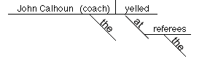
19 | Direct address | Heitor, address the class now. | 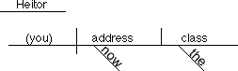
20 | Interjection | Man, that hurt! | 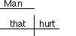
21 | Adjective | Athletic moves excite the crowd.
22 | Compound adjectives | The little old lady hit the tall and distinguished gentleman. | 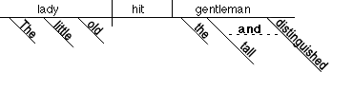
23 | Predicate adjective | Samson was powerful.
24 | Compound predicate adjectives | Samson was powerful but gullible. | 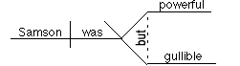
25 | Comparative adjective | Joanna is considerably taller than her brother [is]. | 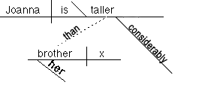
26 | Adverb | Dogsbreath works quickly. | 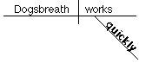
27 | Adverbs modifying other adverbs | A very friendly dog wags its tail quite often. | 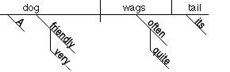
28 | Compound adverbs | Dr. Turveydrop waited patiently and quietly at the door. | 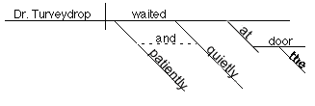
29 | Prepositional phrase | Charles is working in the garden. | 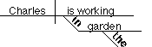
30 | Prepositional phrase modifying another prepositional phrase | Charles is working in the garden by the river. | 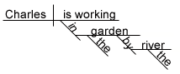
31 | Preposition with compound objects | The thought of getting up and working is alarming. | 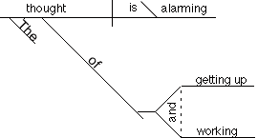
32 | Prepositional phrase modifying an adverb | Tashonda does her best work early  during the semester. | 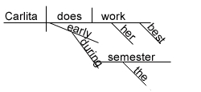
33 | Prepositional phrase as subjective complement | She felt under the weather. | 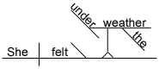
34 | Participle | The crumbling bridge must be repaired. | 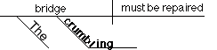
35 | Participial phrase | The screaming crowd watched the bridge falling into the river. | 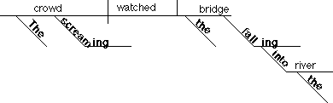
36 | Gerund | Working hard can be profitable. | 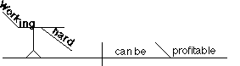
37 | Gerund phrase acting as object | Terminata hates eating broccoli.
38 | Gerund phrase as object of a preposition | Wolfson wrote a book about playing basketball. | 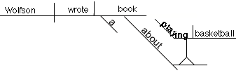
39 | Infinitive as noun (subject & predicate) | To know him is to love him.
40 | Infinitive acting as adjective | His decision to leave early was unfortunate. | 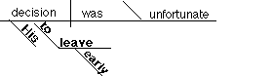
41 | Infinitive acting as adverb | He is determined to work hard. | 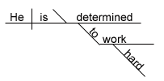
42 | Infinitive as direct object | The Eagles slowly began to climb the national rankings. | 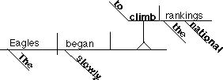
43 | Infinitive phrase as object of preposition | Pedrito had no choice except to run away. | 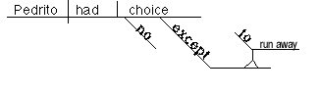
44 | Infinitive phrase as objective complement | Mom wanted me to do the dishes. | 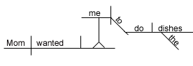
45 | Infinitive phrase as appositive | It was a mistake to elect William president. | 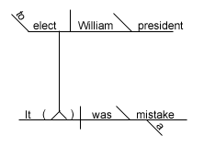
46 | Causative Verb | Professor Villa made her students read four novels. | 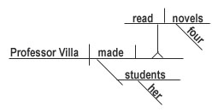
47 | Expletive Construction | There are never enough hot dogs at the annual picnic. | 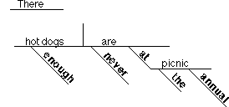
 |  | There is no one working with Albert. | 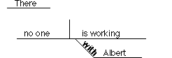
48 | Absolute Construction | To tell the truth, I do not remember meeting her. | 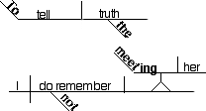
49 | Correlative Conjunction | Either we wash the walls, or we paint them. | 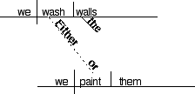
50 | Passive Verbs | The burglar was shot. | 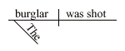
 |  | Mary was awarded the Smith Case. | 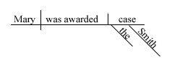
 |  | Turveydrop was named chairman while he was out of the room. | 